National Science Week 2023
Australia’s Annual Celebration of Science and Technology

National Science Week runs each year in August, and it features more than 100 events around the Northern Territory. It includes events delivered by universities, schools, research institutions, libraries, museums, and science centres. In 2023, National Science Week NT will cover a wide range of events in Darwin and Alice Springs, as well as rural towns and remote communities.

Northern Territory Science Week Awards 2023

Have you or do you know someone who has contributed towards an innovative Northern Territory with a technologically skilled workforce, a scientifically literate community, and scientifically well-informed decision-makers?

Let us know! We are looking for our NT STEAM stars.
It is time to recognize our champions who have being promoting Science and Technology in our schools and communities. We will celebrate our wonderful heroes at the Northern Territory Science Week Awards and Launch Night at George Brown Botanic Gardens on the 23rd of September. Winners will receive $250 and we will celebrate their amazing efforts and achievements towards STEAM outreach.

Nominations and Ceremony timeline:
- Nominations will be open from the 17th of July to 25th of August.
- Finalists will be announced on the 31st of August.
- Awards night will happen at George Brown Botanic Gardens on the 23rd of September from 6pm to 9pm.

Selection Criteria
- Self-nominations are allowed.
- Individuals and organizations can be nominated to up to two awards by the same nominee.
- Awards can be given to a specific project or individual, as specified in each category.
- A project is considered an event, activity, workshop, product (online of physical) or program. It can had taken place in one or multiple days, as well as one location or multiple locations.
- The project must had happened in the NT.
- Applicant (organization or individual) must be based in the NT.
- The project main focus must be related to STEAM outreach.
- The project must had happened from the 1st of July 2022 to the 31st of June, 2023.

Awards

- Schools - Sponsored by MAGNT
Awarded to the best school project that has contributed to the increased interest, representation or participation of their students and community in STEAM.

- Outreach Provider – Sponsored by Radical Systems
Awarded to the best project from an outreach provider that has contributed to the increased interest, representation or participation of the general public in STEAM. An Outreach Provider can be an individual or organization such as STEAM related businesses, institutions, museums, parks, NGOs etc.

- Scientist- Sponsored by Ecoz
Awarded to a project lead by a scientist, or a scientist that has contributed to the increased interest, representation or participation of the general public in STEAM.

- Postgraduate - Sponsored by Jackadder International
Awarded to a project lead by a post-graduate student (PhD, Masters by Research and Honours), or post-graduate student that has contributed to the increased interest, representation or participation of the general public in STEAM

- Remote Community – TNRM
Awarded to a project or individual that has contributed to the increased interest, representation or participation of the general public in STEAM in remote communities (Projects in locations outside Darwin, Palmerston and Alice Springs will be considered).

- Remote Schools – Sponsored by NT Heli-Ops
Awarded to the best remote school project that has contributed to the increased interest, representation or participation of their students and community in STEAM.

- Innovation – Sponsored by Kinetic IT
Awarded to the best innovative use of technology in a project that has contributed to the increased interest, representation or participation of the general public in STEAM.

- Promoting Women and Girls in STEM representation – Sponsored by Engineers Australia
Awarded to the best project or individual that has contributed to the increased interest, representation or participation of women and girls in STEAM.

- Best Science Week event - People’s choice – Sponsored by NTG
Awarded to the best Science Week NT 2020 project. Not opened for nominations. Nominations from all awards categories above will automatically enter on this category if they happened during Science Week 2020. The winner will be voted by the public.

- Inspired NT STEM hero of the year – Sponsored by the Power and Water Corporation
Awarded to an outstanding individual with a career in STEAM, that has contributed to the increased interest, representation or participation of youth in STEAM.

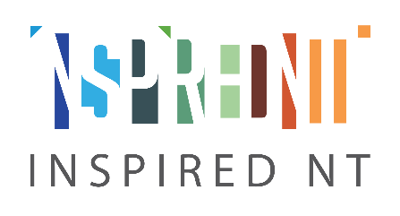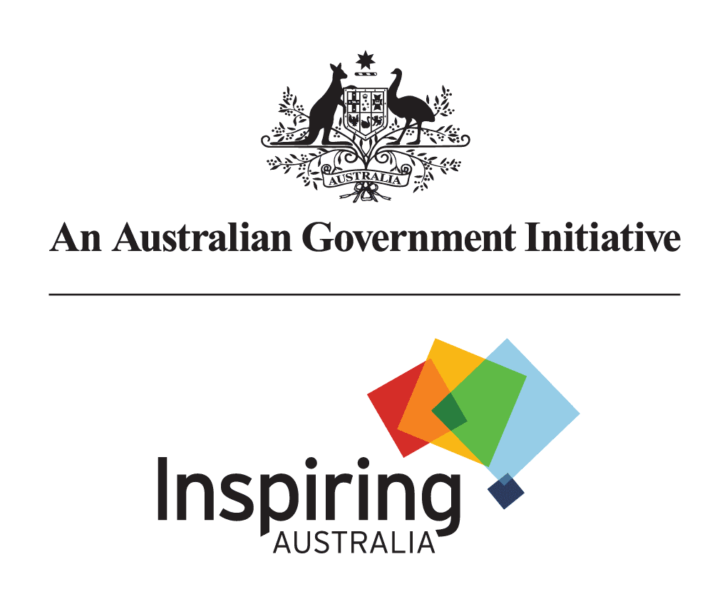

Nomination Form

Northern Territory Science Week Awards - 2023

SECTION 1 – Nominee information
Please provide the nominee information below.
The ‘organisation’ is the company or group in which the nominee works for. If not applicable, please write NA.
If you are nominating a person and not a project, there is no need to provide a project title, please write NA.
Title | First Name | Last Name
Name of Organisation (if applicable):
Project title (if applicable)
e-mail:
phone:
Is this a self-nomination? | ☐ Yes  ☐ No  If no, please provide your:  Name:  Phone:  e-mail:

SECTION 2 – Awards
Select the award most suitable for your nomination (select up to 2 awards):
Each nominee can be selected to up to two categories in the same nomination form.
☐ School
☐ Outreach Provider
☐ Scientist
☐ Postgraduate
☐ Remote Community
☐ Remote School
☐ Innovation
☐ Promoting Women and Girls in STEM representation
☐ Inspired NT STEM hero of the year

Brief Description of the nominee project/activities.
Describe the nominee activities and/or project. How has the nominee contributed towards the award category(s) selected above? Why should the nominee receive this award? Use 250 words or less.

When did the nominee(s) project/activities take place?
Be as specific as possible

Where did the nominee(s) project/activities take place?
Be as specific as possible

Provide nominee media channels (including social media) used to promote the project/activities.
Provide links when available. If no media channels available, please write NA.

If available, please provide evidence that illustrates the nominee project/activities.
We consider evidence: photos, videos, social media links, project evaluation results, comments from the public, attendance numbers etc. Media can be submitted embedded in the form or included as attachments on the submission e-mail.
Indicate if photos and videos can be used on our social media, or if they are for reporting purposes only.
If no evidence available, please write NA.

Please EMAIL your application to:

Carla Eisemberg and Sarah Sutcliffe
EMAIL: inspirednt@cdu.edu.au
PHONE: 08 8946 7721

RECEIPT OF REPORTS WILL BE ACKNOWLEDGE

